5 Grosvenor Grange
H-SOFTENER
Warrington
WA1 4SF
0800 999 6770

www.hydra-clear.com
The softener solution for removal of hardness in water

Softening systems are a tried and tested solution to remove all hardness forming minerals in water. Utilising ion exchange resin to perform the ionic exchange for sodium. The treated water is then prepared for any heat or pressure activities or production requirements.

H-SOFTENER series with integrated control valve, salt bin and water meter. Available in single, double, triple and beyond. Running in various operating states with modern control to allow for easy programming to change quickly and easily.

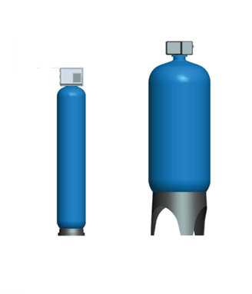

Model Number |  | 100 | 125 | 150 | 200 | 250 | 300 | 350 | 400
Service Flow rate | m3/hr | 3.9 | 4.4 | 5.3 | 7.0 | 8.8 | 11 | 12 | 14
Softener Capacity @ 300ppm | m 3 | 16.6 | 20 | 25 | 33 | 42 | 50 | 58 | 66
Salt Consumption per Regen | Kg | 13 | 15 | 18 | 26 | 31 | 36 | 46 | 51
Electrical Requirements |  | 240 V AC 50/60 Hz Supply with integrated transformer to 24 V AC
Power Rating | W | 65
In/Out Connection Size |  | 2” BSPT Female
Max Pressure | Bar | 7

H-SOFTENER
For private water, industrial and beverage.
Model | Hyda316SS
Connection Size | DN150
Connection Type | PN16 Flanges
Suitable Media | Liquid
Temperature Range | -50°C to 200°C
Material of Wet Contact Parts | 316
Power Supply | 240 V AC/1/50 OR 60 Hz
Output Analogue | 0-10/ 4-20mA 2 wire
Output Digital | Pulsed Frequency
Min Flow | N/A
Max Flow | 40 m³/ Hour
Accuracy | +/- 1%R
Housing IP | IP54
Working Pressure | 9 bar
Max Pressure | 16 bar

